Clustering Individuals Based on Mental Health and Support Satisfaction

Project Description:
I am using the CDC’s Behavioral Risk Factor Surveillance System (BRFSS) 2015 dataset to identify clusters of individuals based on their reported general health, mental health, physical health, and overall life satisfaction. I applied the K-means clustering algorithm twice, each time combining the health variables with a different social determinant of health—household income or education—to explore how these factors relate to health and satisfaction patterns.
The original BRFSS dataset included over 400,000 observations. To ensure the integrity and consistency of the analysis, I removed observations with missing, “unknown,” or “refused” responses across the key health and social variables. After this data cleaning process, I retained 15,032 observations for the analysis. By clustering the health variables with one social variable at a time, I aim to understand how each social factor influences health outcomes independently, providing insights into which social determinants have the strongest impact on perceived health and well-being.
(https://www.kaggle.com/datasets/cdc/behavioral-risk-factor-surveillance-system?resource=download)
Clustering Variables: The primary variables used for clustering focus on individual health perceptions and overall life satisfaction. These variables allow for the identification of distinct health-related patterns among the population.
genhlth (General Health Status):
Higher values of genhlth indicate poorer perceived overall health status. This variable provides a self-reported measure of how individuals view their general health, which is crucial for understanding overall well-being.
menthlth (Number of Days Mental Health Negatively Impacted Life):
A higher value indicates a greater number of days when mental health was reported as poor, impacting daily life. This variable is important for clustering as it captures the frequency of mental health struggles over a month-long period.
physhlth (Number of Days Physical Health Negatively Impacted Life):
Similar to menthlth, a higher value signifies more days when physical health issues affected daily life. Together with menthlth, this provides a comprehensive view of an individual’s physical and mental health.
lsatisfy (Life Satisfaction):
A higher value for lsatisfy indicates lower life satisfaction. This variable reflects an individual’s subjective assessment of their overall quality of life and well-being.
Demographic and Socioeconomic Variables: These variables (income and education) are clustered alongside the health variables to explore the interaction between social determinants of health and individual health perceptions. Each clustering run incorporates one of these variables.

Analysis 1: Health and Income
I determined K = 6 to be optimal using the elbow method.
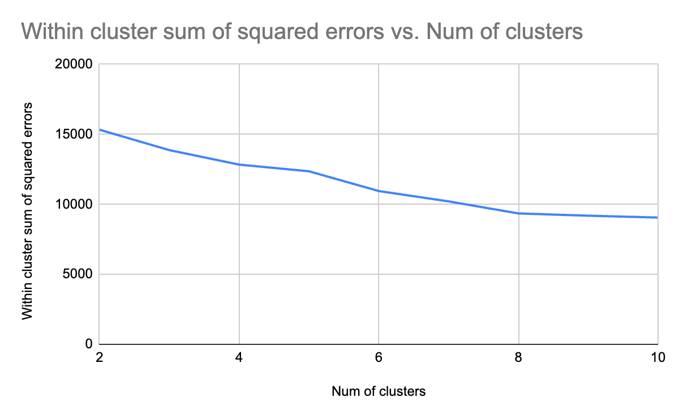
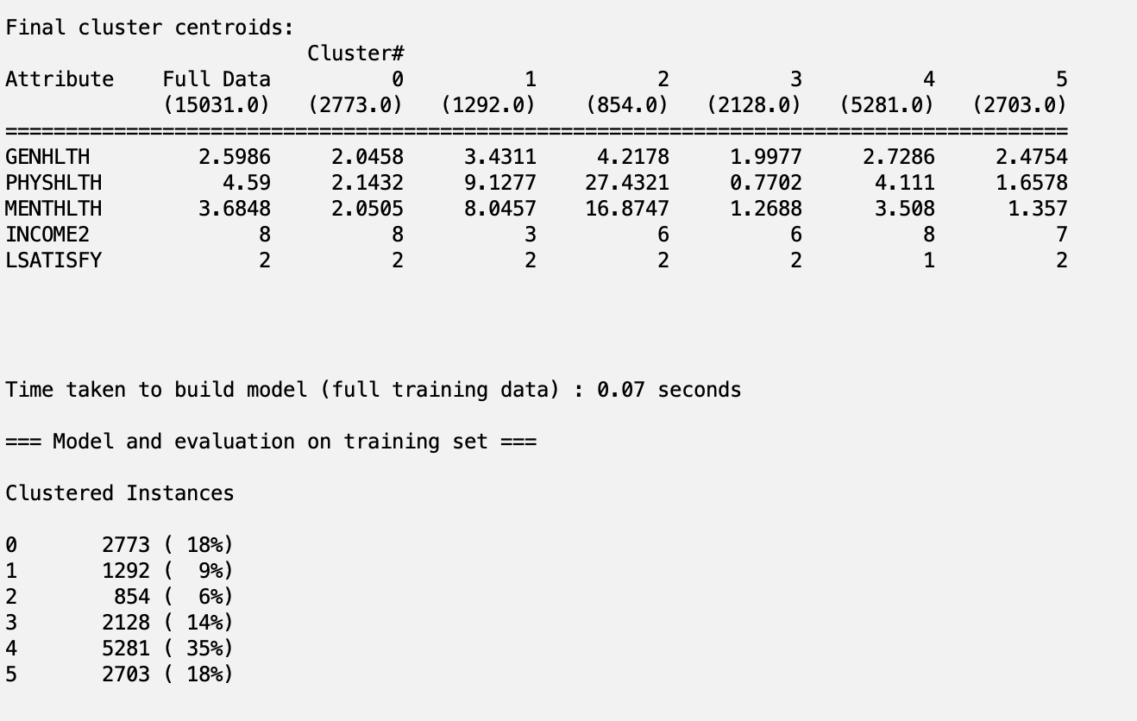
- Cluster 0: This cluster represents 18% of the dataset. Individuals in this group have the highest income (above $75,000) and report high perceived health, both physical and mental. They are generally satisfied with life, indicating a positive overall outlook.
- Cluster 1: Comprising 9% of the dataset, this cluster has the second-worst physical and mental health indicators, with an average of around 9 days of poor physical health and 8 days of poor mental health per month. Despite these challenges, they report general life satisfaction. This cluster also represents the lowest income group, earning between $10,000 and $15,000 a year.
- Cluster 2: This is the smallest cluster, making up 6% of the dataset. It has the worst health indicators, with individuals experiencing an average of 27 days per month where their physical health negatively impacts their daily life and around 17 days per month with poor mental health. Despite these severe health challenges, members of this cluster still report moderate life satisfaction. They fall into the middle-income bracket, earning between $35,000 and $50,000 annually.
- Cluster 3: This cluster includes 14% of the dataset and is in the middle-income range (between $35,000 and $50,000). Individuals in this group report good overall health and relatively high life satisfaction, with minimal issues in both physical and mental health indicators.
- Cluster 4: The largest cluster, accounting for 35% of the dataset, reports the highest life satisfaction levels. This group also has the highest income levels (above $75,000) and generally maintains good health, with a low number of days experiencing poor physical or mental health.
- Cluster 5: Making up 18% of the dataset, this cluster is similar to Cluster 3 but falls into a slightly higher income range (between $50,000 and $75,000). Members report good health and high life satisfaction, with few physical or mental health issues.
The clustering analysis reveals in this dataset that income levels are strongly associated with health outcomes and life satisfaction, with higher income groups consistently reporting better physical and mental health, while lower income groups experience significant health challenges despite maintaining moderate life satisfaction.
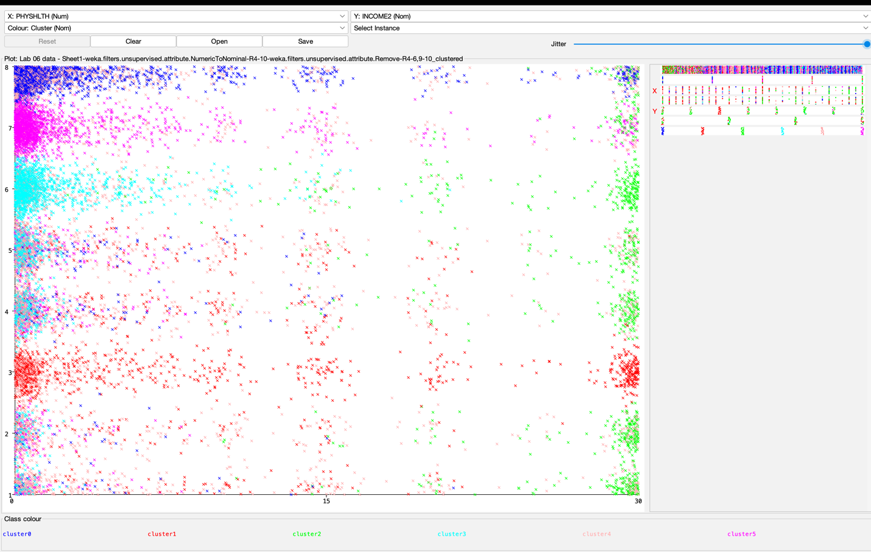This image displays the relationship between income (INCOME2, y-axis) and physical health (PHYSHLTH, x-axis). Clusters 0, 3, and 5 are skewed to the left, indicating that these groups experience fewer days where physical health negatively impacts their daily life. These clusters also belong to the highest income categories, suggesting that higher income groups tend to have better physical health outcomes. In contrast, Cluster 2 is skewed to the right, showing a higher number of days of poor physical health, with income levels spread throughout the range. Clusters 1 and 2 have a denser concentration of observations on the right side, reflecting the groups with the poorest health outcomes, regardless of their income distribution.

Analysis 2: Health and education
I determined k = 9 to be optimal using the elbow method
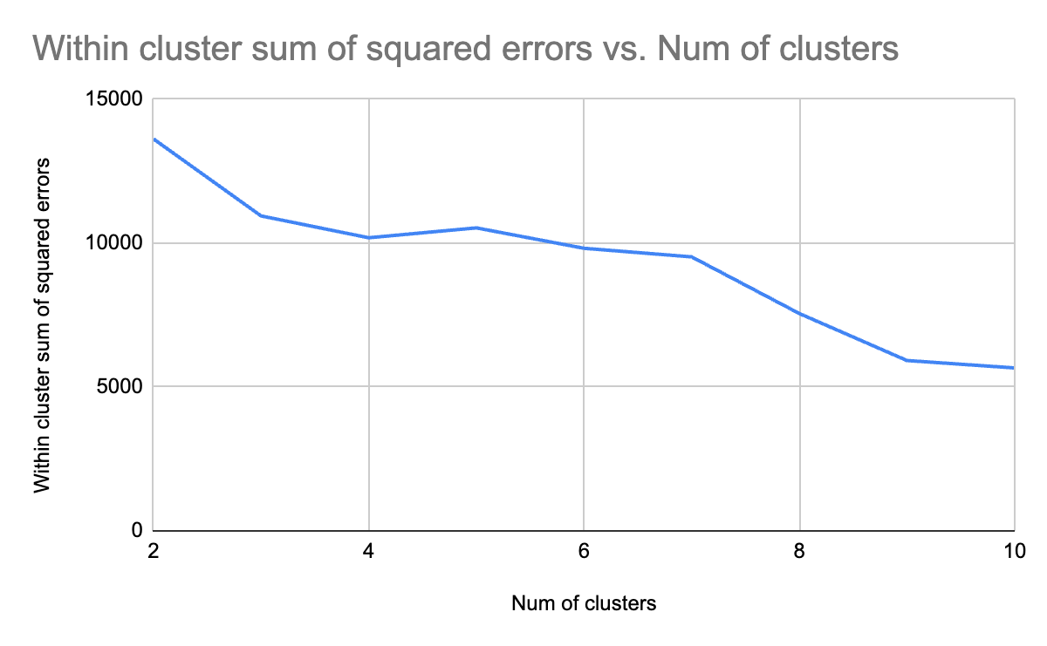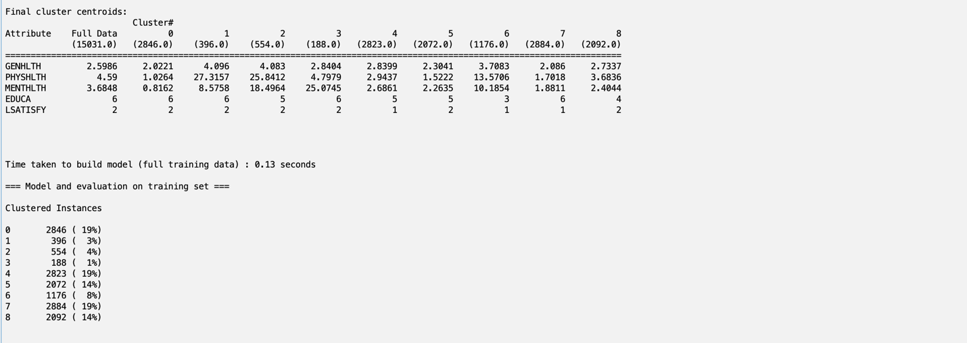
Cluster 0: Comprising 19% of the dataset (2,846 instances), this group reports very good general health, with low numbers of poor physical (about 1 day per month) and mental health days (less than 1 day per month). They are predominantly college graduates and report being satisfied with life. This cluster represents a highly educated and healthy group with minimal health issues.
Cluster 1: This small cluster, making up 3% of the dataset (396 instances), shows fair general health but experiences very high physical health challenges (around 26 days per month) and moderate mental health challenges (about 9 days per month). Despite these issues, the individuals in this cluster are mostly college graduates and report being satisfied with life, highlighting a group where health challenges persist despite educational attainment.
Cluster 2: Representing 4% of the dataset (554 instances), this cluster exhibits fair general health but has the worst health indicators, with an average of 26 days of poor physical health and around 18 days of poor mental health per month. Members of this group have some college or technical education and still report being satisfied with life, despite their severe health challenges.
Cluster 3: The smallest cluster, accounting for 1% of the dataset (188 instances), reports good general health but experiences a high number of poor mental health days (about 25 days per month) compared to physical health issues (about 5 days per month). These individuals are primarily college graduates and report being satisfied with life, suggesting that mental health is a predominant issue for this group.
Cluster 4: Making up 19% of the dataset (2,823 instances), this cluster reports good general health, with relatively few days of poor physical (about 3 days per month) and mental health (around 3 days per month). The majority are college graduates, and they report the highest life satisfaction, indicating a well-educated and overall healthy group.
Cluster 5: This cluster consists of 14% of the dataset (2,072 instances) and includes individuals with very good general health, experiencing minimal physical (around 2 days per month) and mental health issues (about 2 days per month). Most have some college education, and they report being satisfied with life, reflecting a group with a generally good quality of life and moderate educational attainment.
Cluster 6: Comprising 8% of the dataset (1,176 instances), this group reports fair general health and experiences a moderate-to-high number of poor physical health days (around 14 days per month) and mental health issues (around 10 days per month). Despite these health challenges, they are high school graduates and report being very satisfied with life, indicating that other factors may be contributing positively to their well-being.
Cluster 7: The largest cluster, making up 19% of the dataset (2,884 instances), has very good general health and reports very few poor physical (about 2 days per month) and mental health days (about 2 days per month). Members of this group are primarily college graduates and report the highest level of life satisfaction, representing a well-educated and healthy population.
Cluster 8: Accounting for 14% of the dataset (2,092 instances), this cluster shows good general health, with a moderate number of days affected by poor physical health (around 4 days per month) and a few days of poor mental health (around 2 days per month). The individuals in this group are mainly high school graduates and report being satisfied with life, reflecting a middle-ground group in terms of health and educational attainment.
The clustering analysis highlights that higher education levels are consistently associated with better physical and mental health outcomes and higher life satisfaction, while clusters with lower educational attainment or severe health challenges demonstrate variability in life satisfaction, suggesting the presence of other influential factors beyond socioeconomic status.
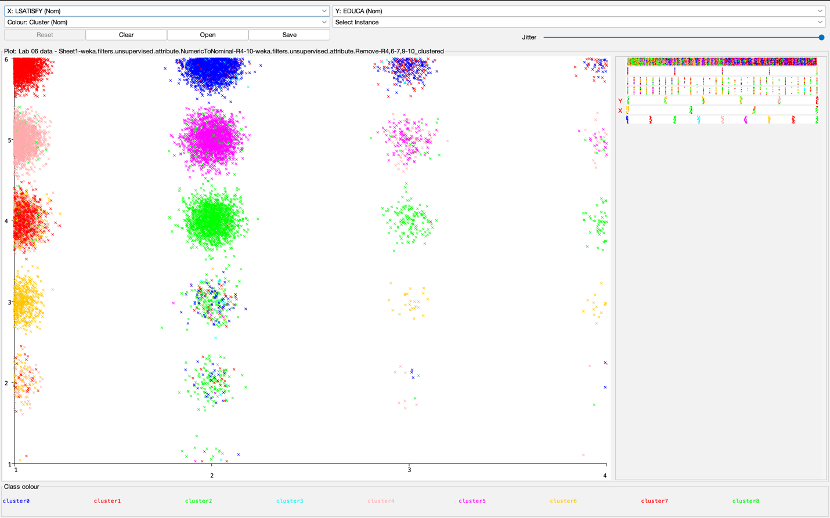In general, the majority of the data set reported high or moderate life satisfaction. Clusters 0, 1, and 4 show high concentrations toward the left side of the plot, indicating high life satisfaction. These clusters also represent individuals with the highest levels of educational attainment (primarily college graduates). In contrast, Cluster 2 displays the widest spread in life satisfaction levels and consists mostly of individuals with high school education or lower.

- Limitations Due to Homogeneity:
  - Given that this dataset is predominantly composed of white and highly educated individuals, the insights derived from this clustering analysis are limited in their generalizability. The findings may not adequately capture the experiences of other racial or ethnic groups, particularly those with lower levels of education or different socioeconomic backgrounds. This lack of diversity highlights a need for datasets that are more representative of the broader American population, ensuring that public health interventions and analyses are more inclusive.
- Exploration of Contextual Factors:
  - While the relationship between income, education, and health outcomes is expected, adding contextual factors such as access to healthcare, employment benefits (e.g., health insurance), and community support networks could provide a more nuanced understanding of why certain groups experience better health outcomes. Exploring these contextual variables might reveal protective factors or risks beyond just income and education levels.
- Overcoming the Limitations of K-Means Clustering:
  - K-means clustering is a simple and effective method, but it has its limitations, particularly when dealing with variables that have non-linear relationships or when the data is not evenly distributed. Future analyses could explore other clustering techniques, such as hierarchical clustering or density-based clustering (DBSCAN), which may better capture the natural groupings within more complex or imbalanced datasets.
- Considerations for Future Data Collection:
  - In future studies, it may be beneficial to collect additional data points, such as racial identity, access to mental and physical healthcare, and prevalence of chronic diseases. Including these variables would allow for more detailed clusters that consider the intersection of multiple health and social factors, potentially uncovering disparities not visible in the current dataset.
- Reflection on the Practice and Limitations of Weka:
  - Weka provides an accessible platform for running K-means clustering, making it a useful tool for practicing basic clustering techniques. However, its capabilities are limited when it comes to more advanced analyses, such as handling higher-dimensional data or incorporating feature engineering. In future analyses, utilizing Python with libraries like Scikit-learn or TensorFlow may allow for a more flexible and powerful approach, enabling more complex models and deeper insights into the relationships between variables.
- Actionable Steps for Improvement:
  - To strengthen this analysis and improve the robustness of future work, I plan to expand the dataset to include more diverse groups and additional health indicators. By incorporating more demographic variables and applying advanced clustering techniques, I aim to provide a more comprehensive view of the factors influencing health outcomes and life satisfaction in the U.S. population.

Resources
•More Data Mining with Weka (3.6: Evaluating clusters)
•Weka Tutorial for Non-Technical People - Simple K-Means Clustering Algorithm
•https://medium.com/analytics-vidhya/how-to-determine-the-optimal-k-for-k-means-708505d204eb
•https://sites.google.com/site/dataclusteringalgorithms/k-means-clustering-algorithm

